Date -21/10/2023

Roll No. - 25

Expt. No. - 6

K.M.S.P. Mandal’s

Sant Rawool Maharaj Mahavidyalaya, Kudal

**Department of Computer Science**

Signature

Recovering and inspecting deleted files using Autopsy.

Title - _______________________________________________________

_______________________________________________________

Autopsy is a digital forensics platform and graphical interface to The Sleuth Kit and other digital forensics tools. It is used by law enforcement, military, and corporate examiners to investigate what happened on a computer. You can even use it to recover photos from your camera’s memory card.

Basically, the autopsy is a free open-source tool that supports a wide range of other digital forensics modules and tools.

The **Autopsy** is computer software that makes it simpler to deploy many of the open-source programs and plugins used in [The Sleuth Kit](https://en.wikipedia.org/wiki/The_Sleuth_Kit).The graphical user interface displays the results from the forensic search of the underlying volume making it easier for investigators to flag pertinent sections of data. The tool is largely maintained by [Basis Technology Corp.](https://en.wikipedia.org/wiki/Basis_Technology_Corp.) with the assistance of programmers from the community.

## Features-

* **Multi-User Cases**: Collaborate with fellow examiners on large cases.
* **Timeline Analysis**: Displays system events in a graphical interface to help identify activity.
* **Keyword Search**: Text extraction and index searched modules enable you to find files that mention specific terms and find regular expression patterns.
* **Web Artifacts**: Extracts web activity from common browsers to help identify user activity.
* **Registry Analysis**: Uses RegRipper to identify recently accessed documents and USB devices.
* **LNK File Analysis**: Identifies shortcuts and accessed documents
* **Email Analysis**: Parses MBOX format messages, such as Thunderbird.
* **EXIF**: Extracts geo location and camera information from JPEG files.
* Media Playback and Thumbnail viewer.
* **Robust File System Analysis**: Support for common file systems, including NTFS, FAT12/FAT16/FAT32/ExFAT, HFS+, ISO9660 (CD-ROM), Ext2/Ext3/Ext4, Yaffs2,
* **Unicode Strings Extraction**: Extracts strings from unallocated space and unknown file types in many languages
* **File Type Detection** based on signatures and extension mismatch detection.
* Interesting Files Module will flag files and folders based on name and path.
* **Android Support**: Extracts data from SMS, call logs, contacts, Tango, Words with Friends, and more.

Create New Case

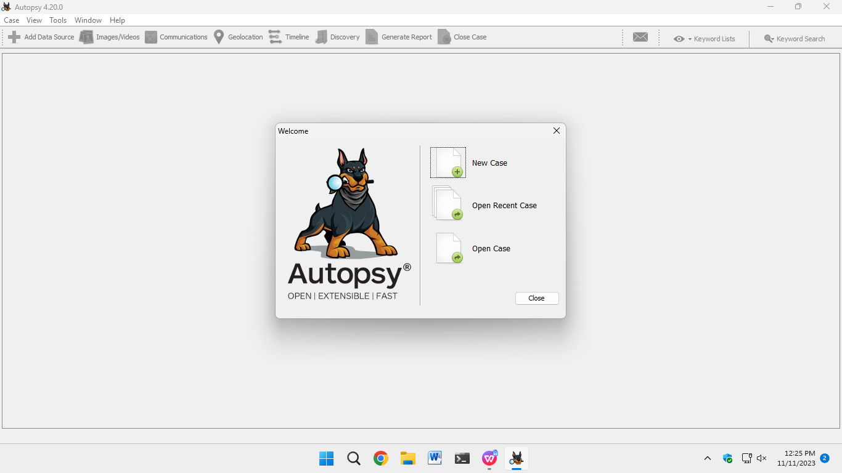

Case Information

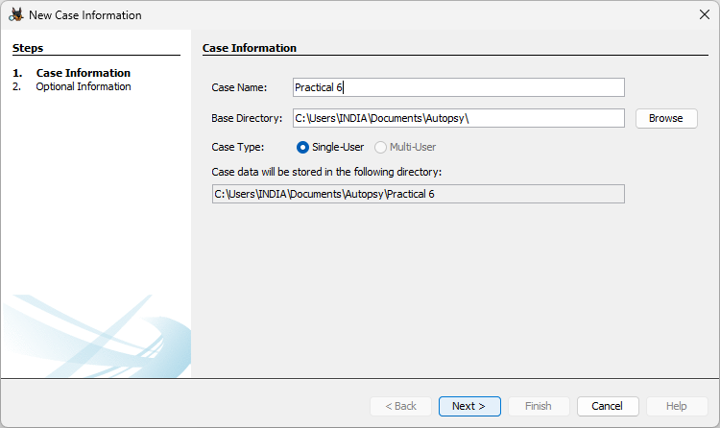

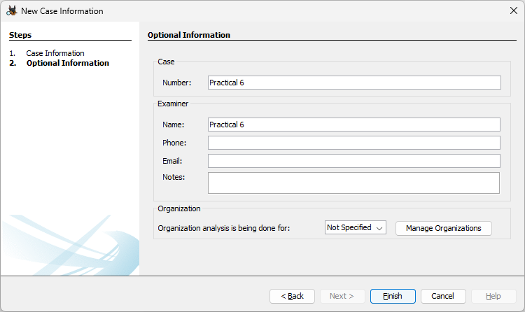

Select Disk for Scan

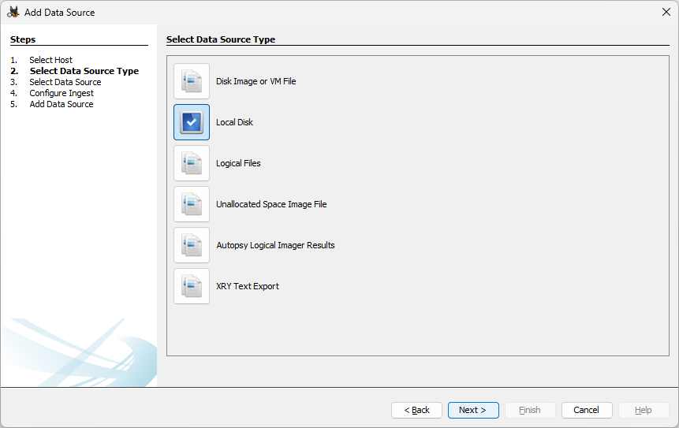

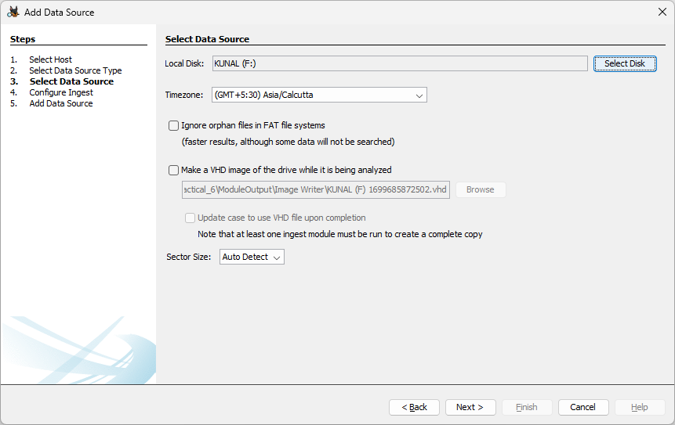

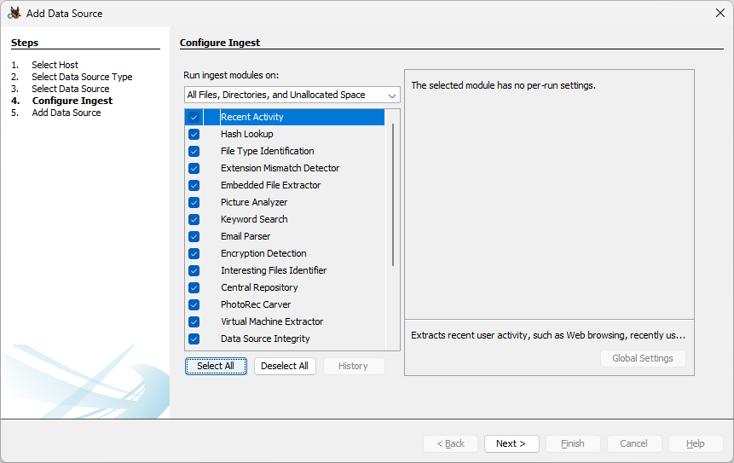

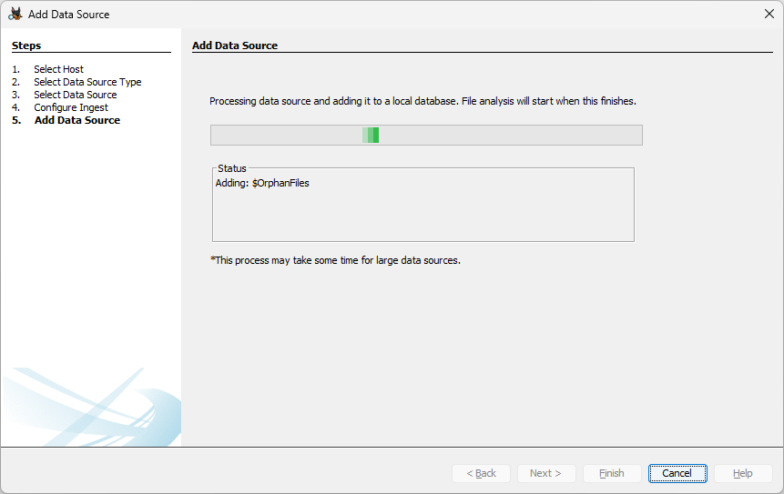

Data Scan Complete

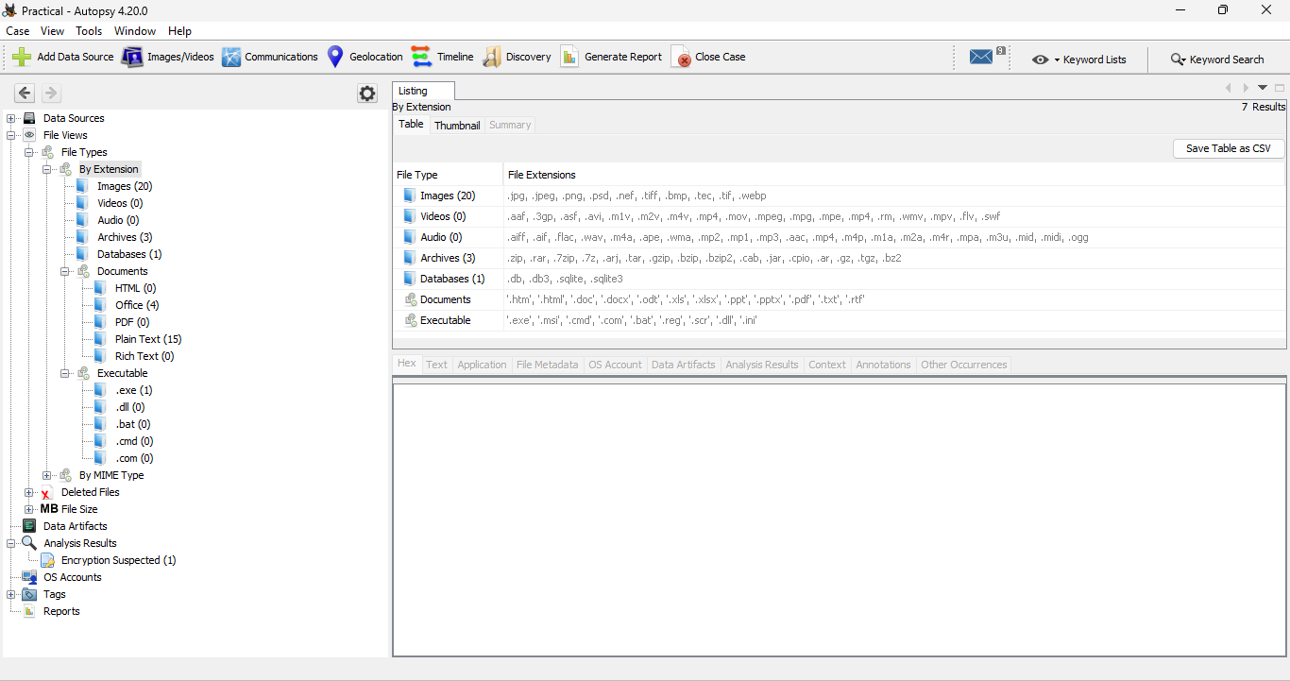

Data Scan Result

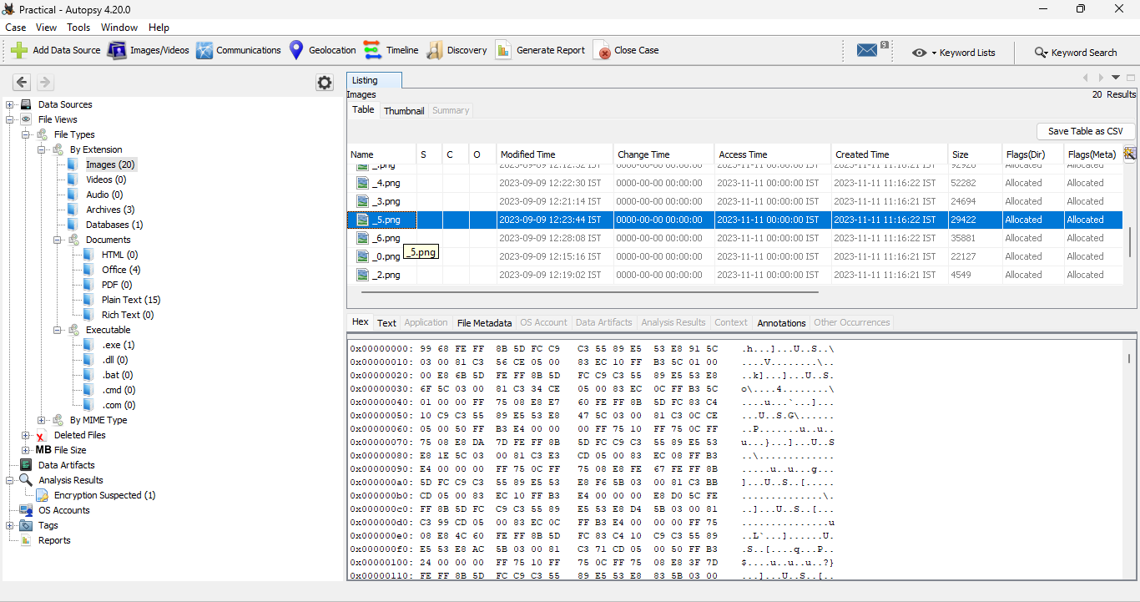

Generating Report in Excel Format

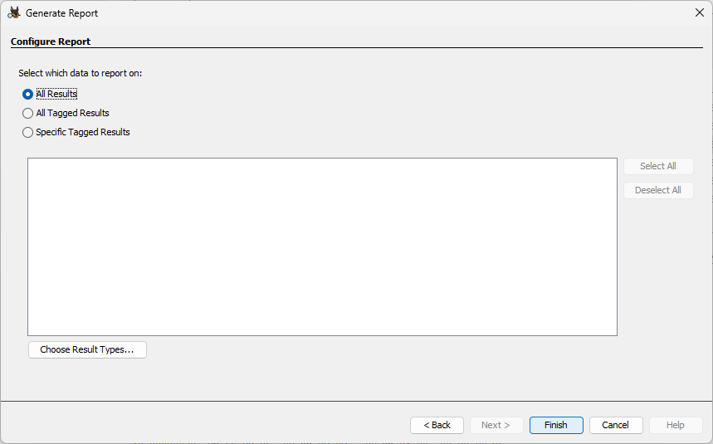

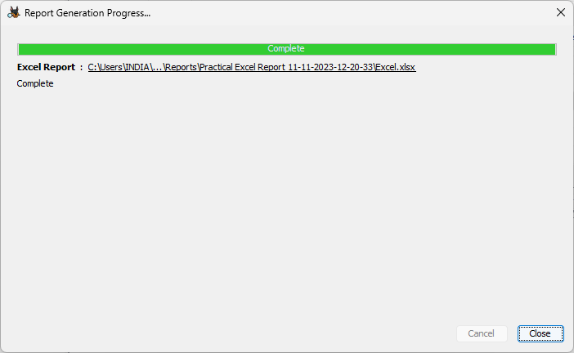

Generated Report

